SmileFoundation - Website

Exam assignment

150096724010

**Problem statement:**  
  
Smile Foundation works to improve the lives of underprivileged children through education and healthcare. The website needed to clearly communicate their programs, success stories, and donation options. It required functionality to enable easy volunteer sign-ups and transparent fund tracking to build trust with supporters.

The key challenges identified were:

Live link - <https://smile-foundation-lime.vercel.app/>

* Lack of clear communication about various programs and initiatives
* Difficulty in volunteer registration and management
* Limited transparency in donation tracking and fund utilization
* Need for compelling presentation of success stories to inspire support
* Requirement for a responsive design that works across all devices
* Business model - <https://docs.google.com/spreadsheets/d/1aLN_CwsimwQU2D98G1DsB52mKR4B3pkvLq_hAUvSr-E/edit?usp=sharing>

## **Tools & Technologies Used:**

### **Frontend Development**

* **HTML5**: Used for creating semantic structure with accessibility features for program descriptions, donation forms, and success stories.
* **CSS3**: Implemented a clean, warm design reflecting hope and support, with responsive layouts using Flexbox and Grid for all device sizes.
* **JavaScript**: Developed interactive elements including:
  + Real-time form validation for donations and volunteer sign-ups
  + Dynamic content loading for success stories
  + Interactive state selection for volunteer registration
  + Animated statistics and impact counters

### **Design & Planning**

* **Figma**: Created comprehensive wireframes and prototypes for:
  + User journey mapping for donation flows
  + Volunteer registration process
  + Impact storytelling sections
  + Mobile-responsive layouts
* Link - <https://www.figma.com/design/HRKqMoontW4SCiFwMNTomV/SmileFoundation?node-id=0-1&t=xGM2Elb6IuruEr61-1>

### **Version Control**

* **Git**: Maintained code versioning and collaboration

## **Pricing Strategy & Product Flow**

### **Donation Tiers**

Designed a multi-tiered donation structure:

* **One-time donations**: Flexible amounts with suggested tiers (₹1500, ₹3000, ₹6000, ₹12000)
* **Monthly sponsorships**: Recurring donation options with clear impact descriptions
* **Program-specific funding**: Allowing donors to direct funds to specific initiatives
* **Corporate partnerships**: Custom packages for business supporters

### **Transparent Fund Allocation**

Implemented a transparent fund tracking system:

* Visual breakdown of how donations are utilized
* Real-time updates on program funding progress
* Detailed annual reports accessible through the platform
* Impact stories directly linked to specific funding initiatives

Website:

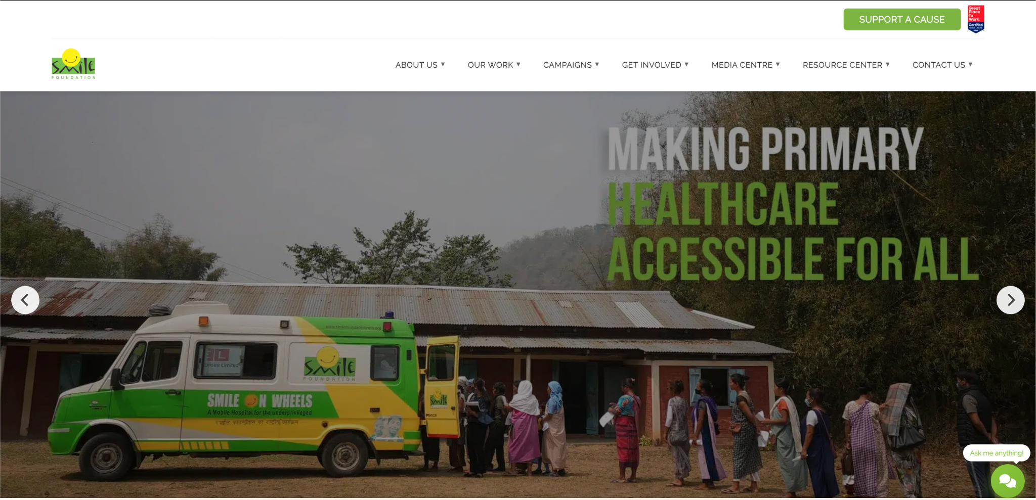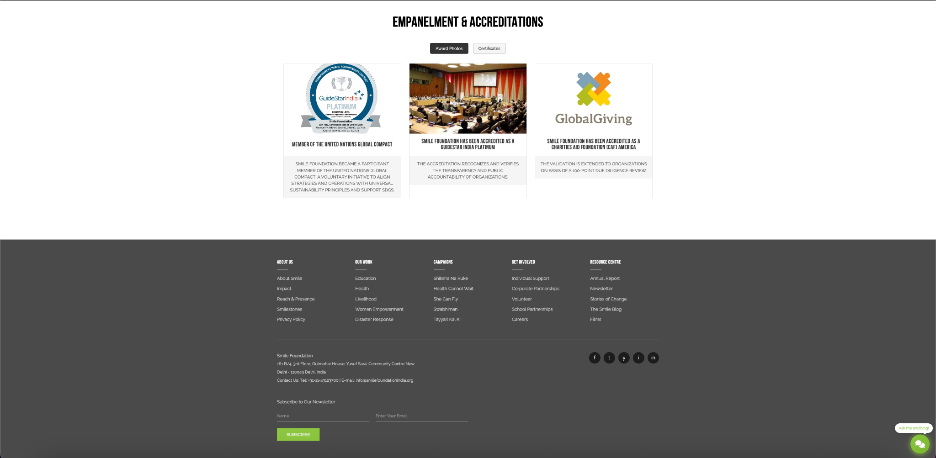

Figma:  
  
